**POISSON PROCESS**

**Q: Suppose the customers enter a certain shop at the rate of 30 persons an hour. Using the Poisson distribution, calculate the probability that in a 2-minutes interval, no customer will enter the shop.**

**SOLUTION:**

**DATA**

Rate = λ = 30 persons per 1 hour

Probability no customer enter = P (X = 0) = ?

Time Interval = t = 2 minutes = 2/60 = 1/30 per hour

**FORMULA:**

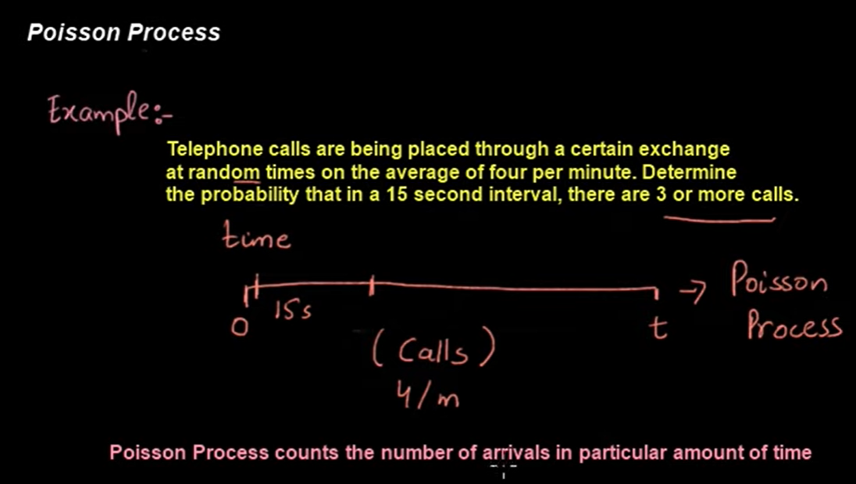

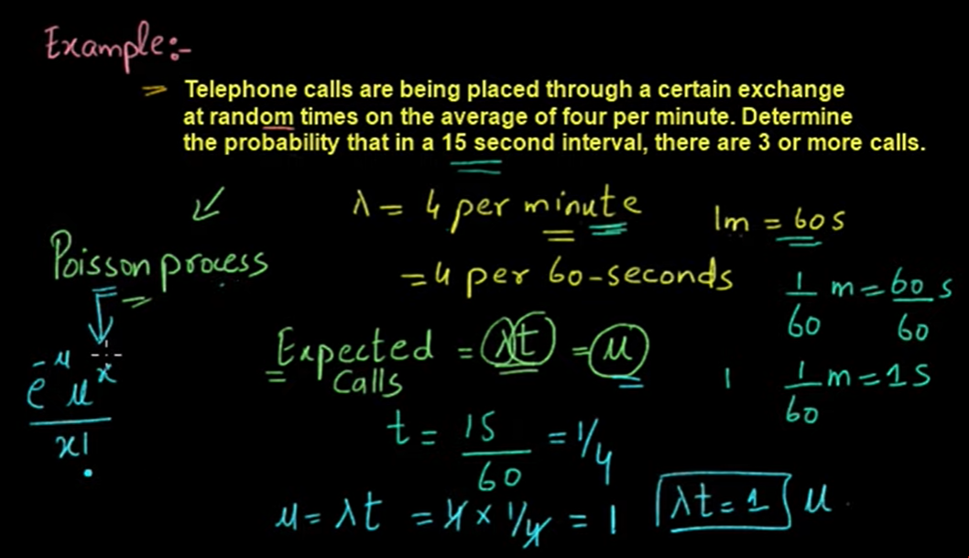

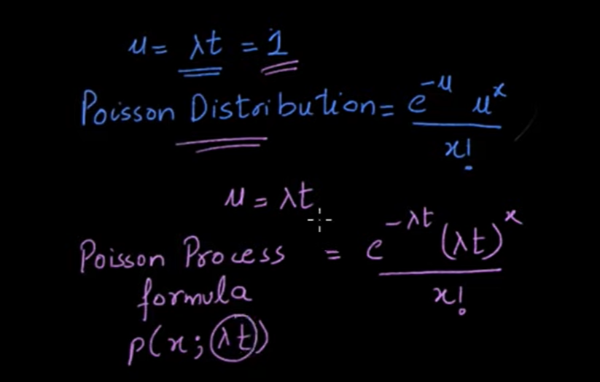

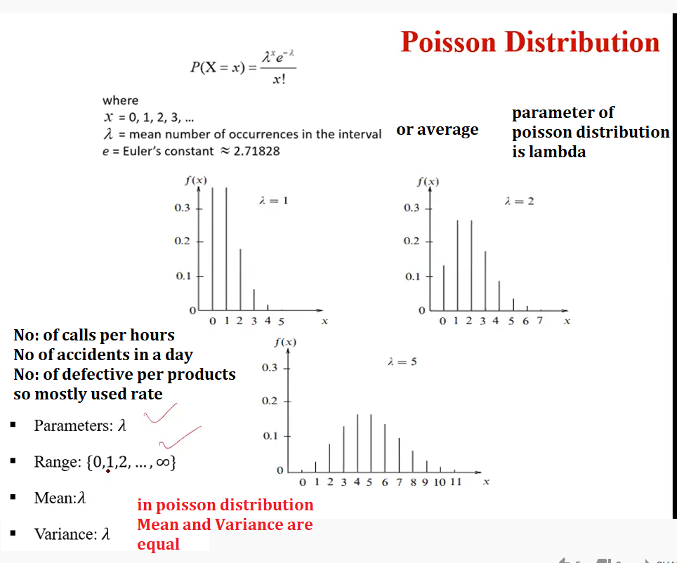

Q: Define Markov Process

Q: What do you mean by Balking, Reneging of a queuing system?

Q: State Little’s formula for the Queueing model (M/M/1): (K/FIFO)

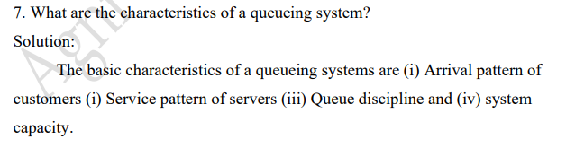

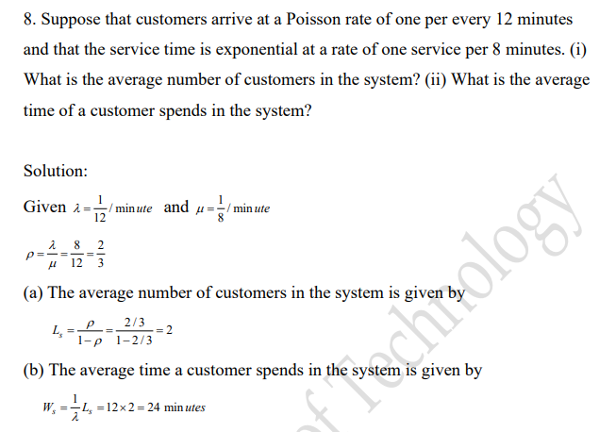

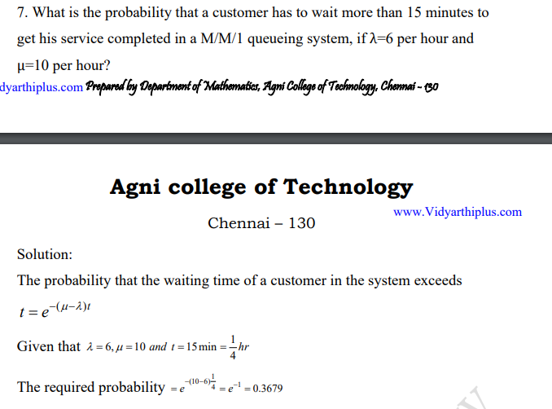

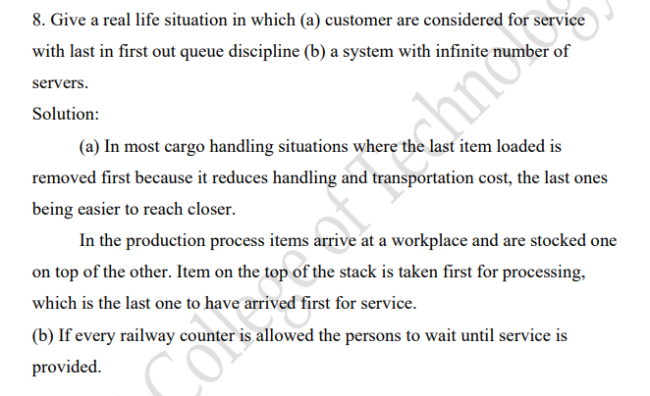

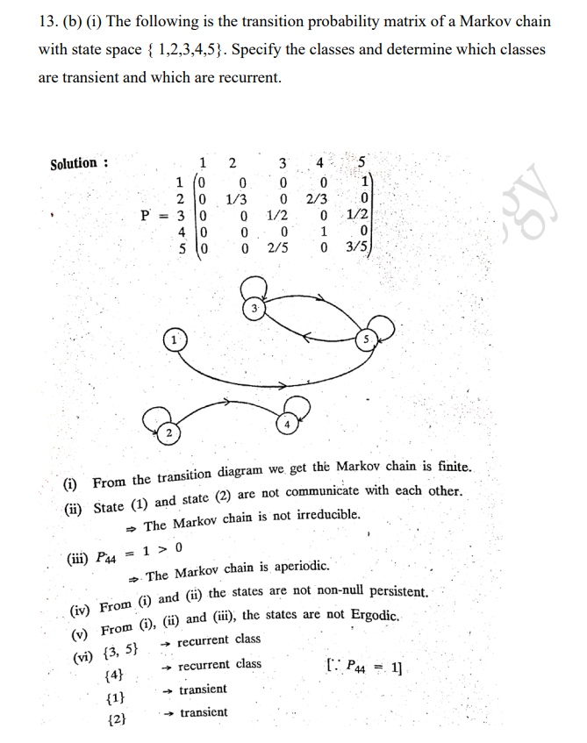

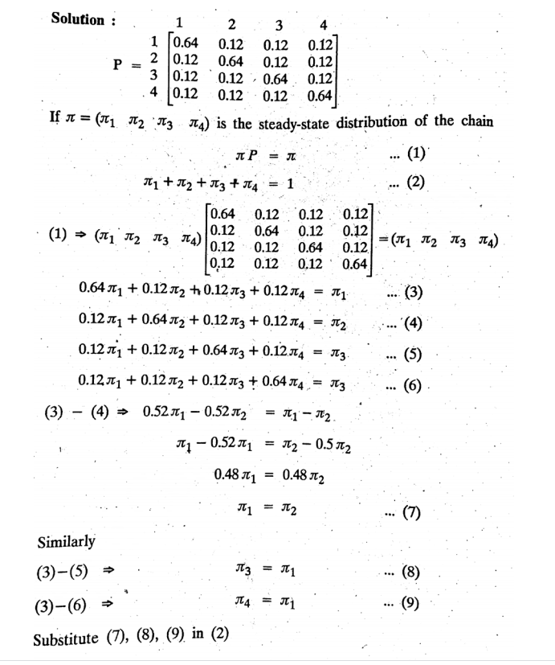

Q:

SOLUTION:

Subtract (A) – (B)

Similarly, subtract (A) – (C)

Similarly, subtract (A) – (D)

Put the value of (A), (B), (C) and (E) in equation (2)